1. Open link: <https://account.line.biz/> and Create New Business account. You can create an account through your mobile app or email. In this manual further registration is described for email.

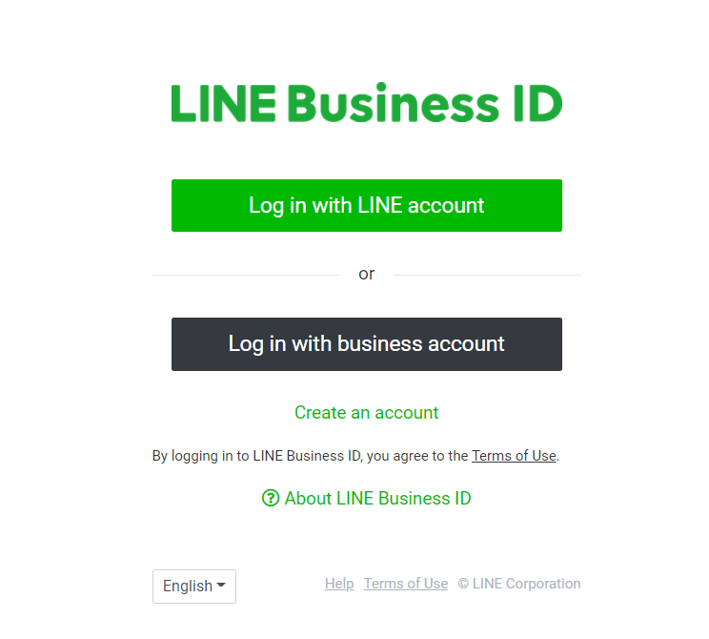

1. Register new Account through email
2. 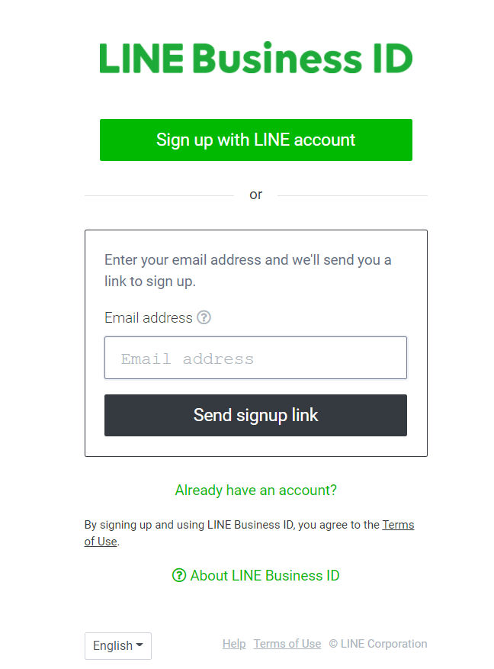Create a new one and add needed information about your company.

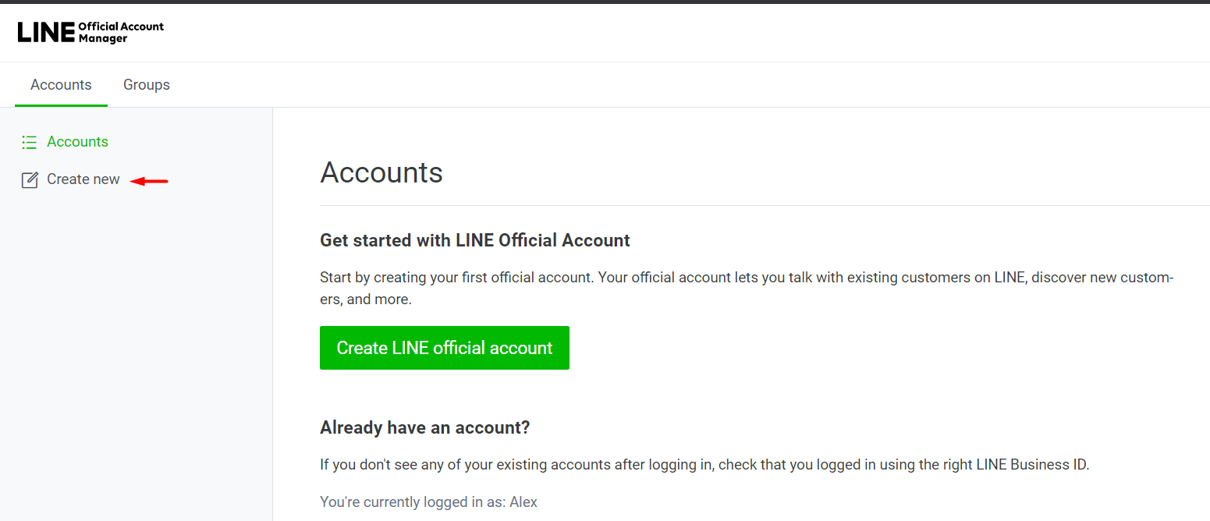

A letter will be sent to the email specified earlier. Click the Continue button in this email

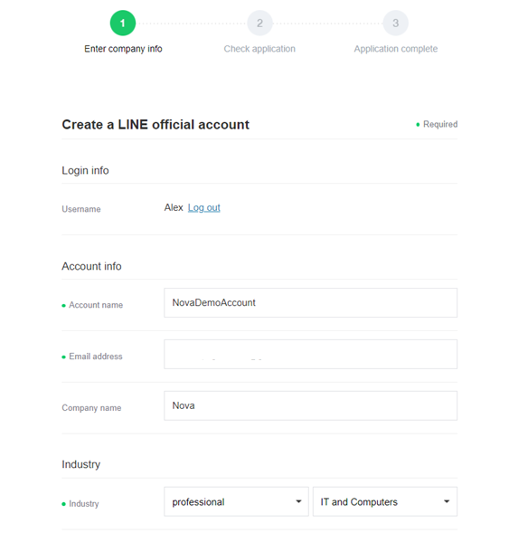

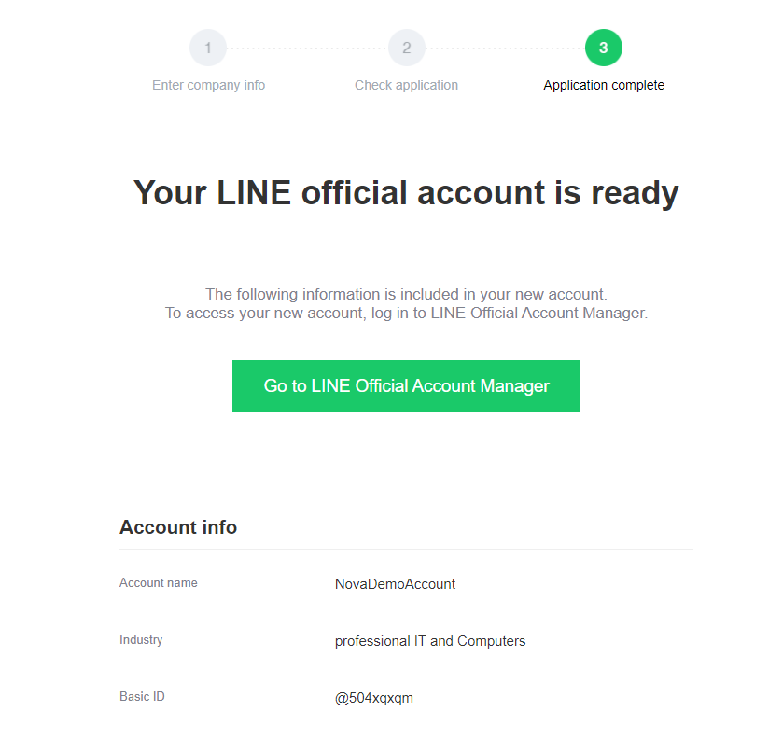

1. Open link: <https://developers.line.biz/console/> and create a **Provider** and obtain a **Token** that should be sent to us

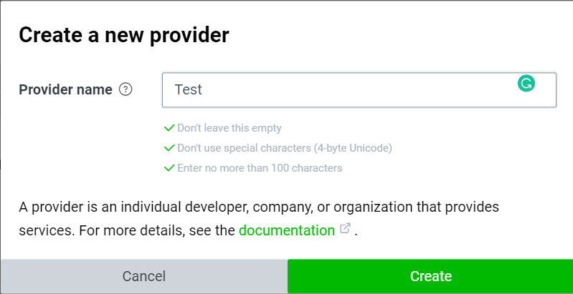

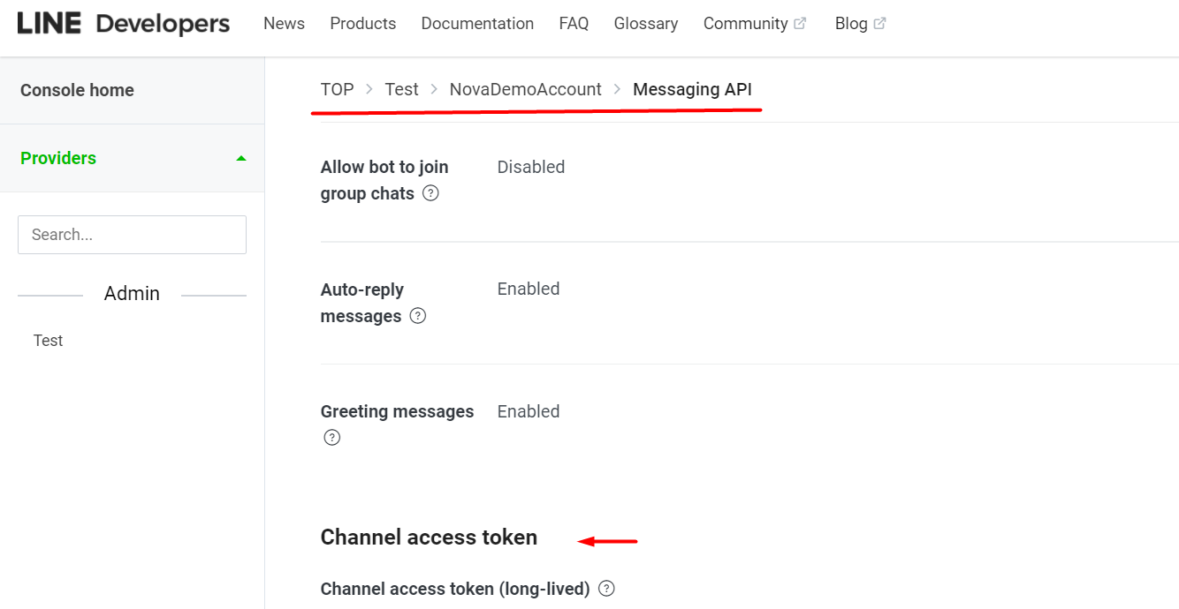

1. 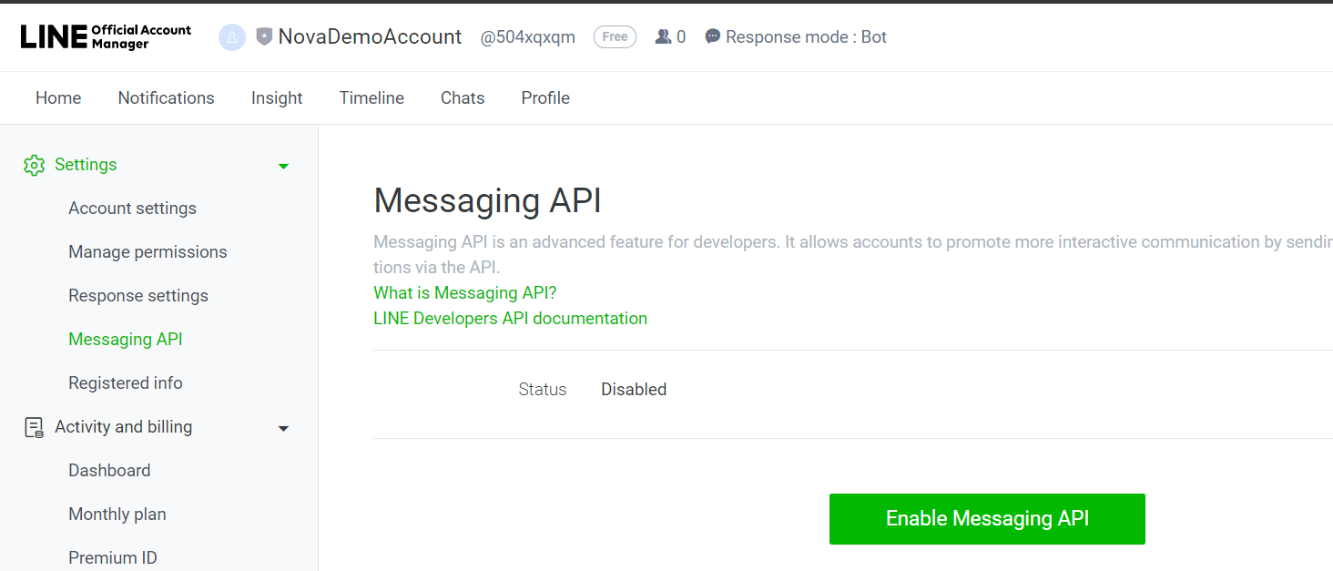Return to <https://manager.line.biz/> and enable Messaging API, fill needed info.
2. Send your Channel Secret to us and we will send your **webhook**. Place our **webhook** to your account’s settings:

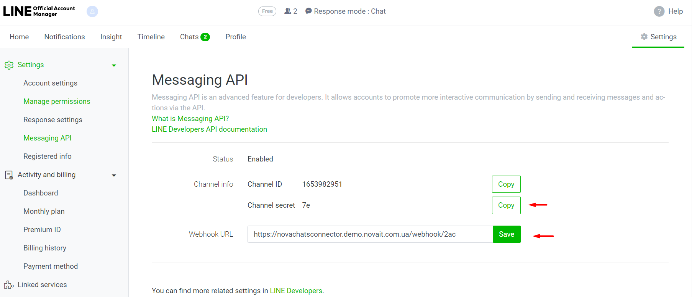

1. After adding the webhook let us know and we will check how it’s work.